Installation Manual

There aren’t many things to mention for “running” this web application. But something that is important is to have the files in the form of:

project (folder) images (folder) **(1)**  
 serverUploadPath (folder) **(2)**  
 all the other files (php, css, js) **(3)**

1. The images folder needs to have four folders called: login, main, settings, signup in which all the respective images are stored.
2. This is the directory in which the uploaded files (images) are stored.
3. The files should be:

detailedInternship.css

detailedInternship.js

detailedInternship.php

login.css

login.php

loginValidate.php

mainpage.css

mainpage.js

mainpage.php

processSearchInput.php

searchpage.css

searchpage.js

searchpage.php

settings.css

settings.js

settings.php

signup.css

signup.js

signup.php

validate_input.php

Generally you need XAMMP to use it and also when it comes to the database (the name should preferably be “searchinternships_database”), one should be created based on this schema:

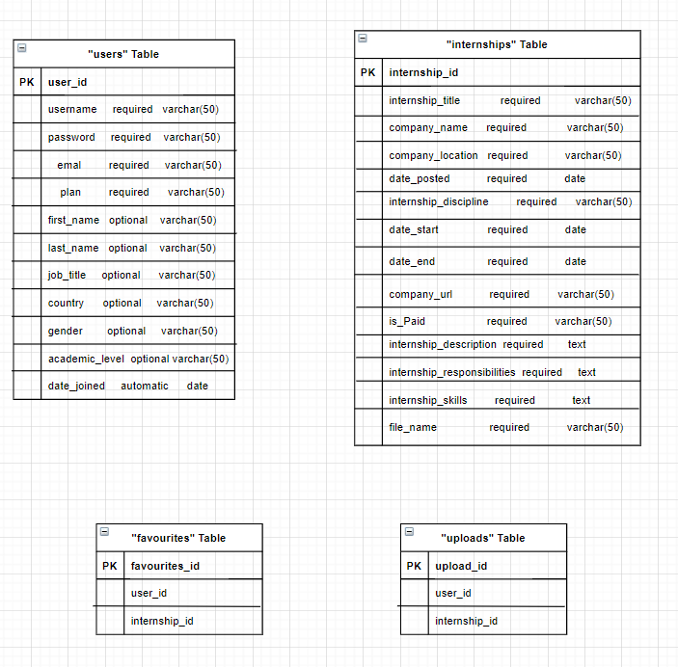

All column attributes are required to be created. The characterization of “required” and “optional” are not meant to say that those attributes are not important to be part of the database. It is related to whether these data are required to be given by the user or not.

After the database is created, there is the need to change some lines of code in the files in order to use the database with one of your users (and not the one that the author uses). Meaning that the second and third arguments should be changed to one of your own user’s username and password, respectively.

Example: $con = mysqli_connect('localhost', 'fanis', 'JK3245', 'searchinternships_database');

1. In the file processSearchInput.php in the line 2.
2. In the file detailedInternship.php in the line 26.
3. In the file loginValidate.php in the line 5.
4. In the file settings.php in the lines 27, 38, 252, 472, 532, 634, 689, 750, 767.
5. In the file validate_input.php in the line 5.

To avoid the hustle, you can create a user account with the same username and password mentioned above.